

Tender Response Creation
Submitted To
User Manual – Supplier Portal
DOCUMENTATION FOR

Document Control
Date | Author | Version | Change Reference
27-Mar-24 | Govarthan S | V1.0 | Initial Version
Change Record

Reviewers
Name | Position
Cyril Joshua R | Solution Architect, 4iapps
Kavin Rama M | SCM Functional Consultant, 4iapps

Approvers
Name | Position | Signature
Mr. Kamal Al Harrasi | Project Manager, OMRAN
Mr. Shagul Hameed | Project Manager, 4iapps
 | Head of IT, OMRAN
 | Head of Procurement, OMRAN

Distribution
Copy No. | Name | Location
1 | Kamal Al Harrasi | Omran Group

Contents

1. Introduction 3
2. Tender Response Creation 3

Customize the text for your project, as appropriate.

Introduction
As a supplier user you can view the Active tender from the Buying Organization and Acknowledging your intent to participate in a negotiation only notifies the buyer company that you're interested in responding to the negotiation.
After you have viewed the details of the negotiation document, you can determine the best response to create. The response document generated will help you provide a complete response by providing all necessary information.
Throughout the responding process, you can communicate with the buying organization by using online messaging. You can participate in multiple online conversations within the context of a negotiation. All messages you initiate are addressed to the buying organization and can be viewed by all members of the buying organization who are also participating in the negotiation. You can reply to message you're sent by an individual participant of the buying organization.

Tender Response Creation
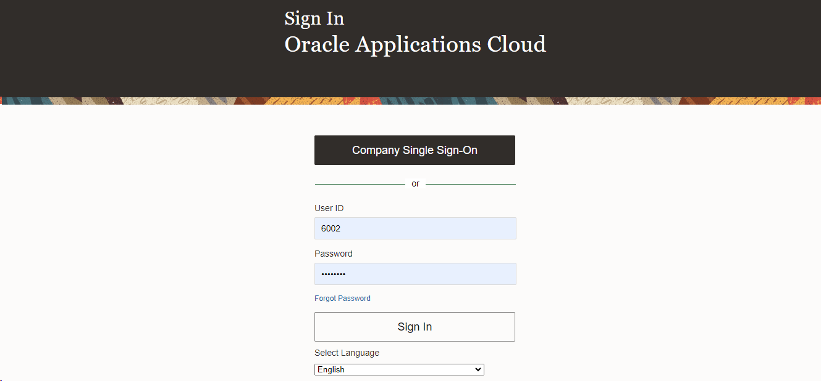
Step | Action
 | Login with Company Single Sign-On, Log in as Supplier Portal Credentials with Username and Password.

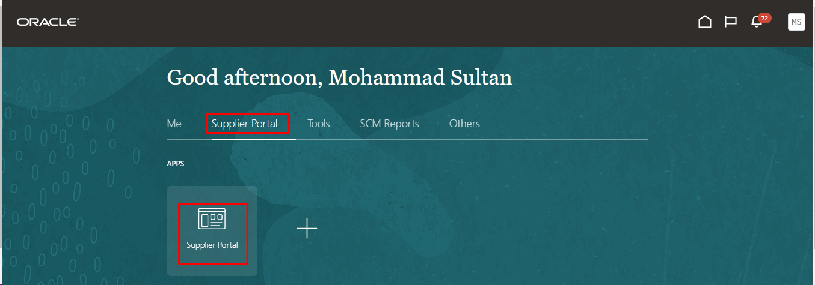
Step | Action
- Navigate to Supplier Portal Supplier Portal
Note: The Supplier Portal page includes an integrated search facility to locate particular orders, agreements, shipments, and so on, a Tasks list from which to access all Supplier Portal tasks and reports, and a number of dynamically updated infolets. Infolets provide interactive graphic readouts of critical real time information, such as supplier transaction reports.

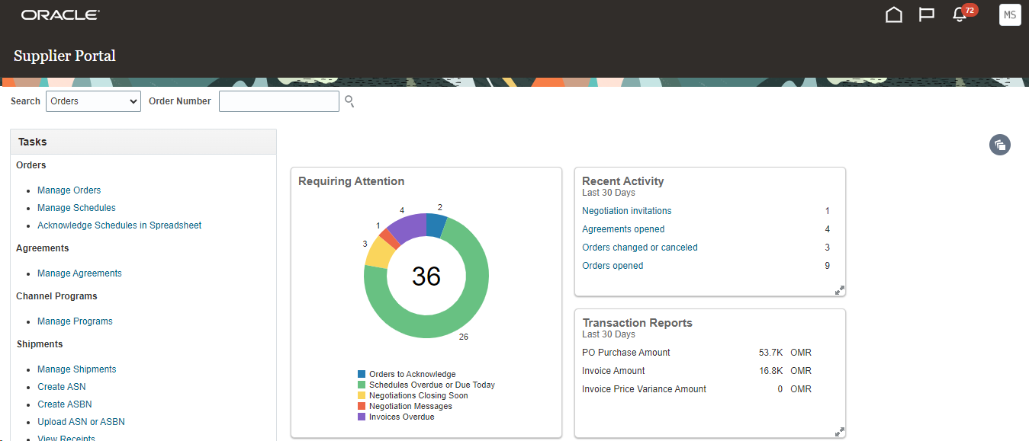
Step | Action
 | - Dashboard will be seen when the supplier portal is opened. It displays the list of pending and on-going task of a supplier.

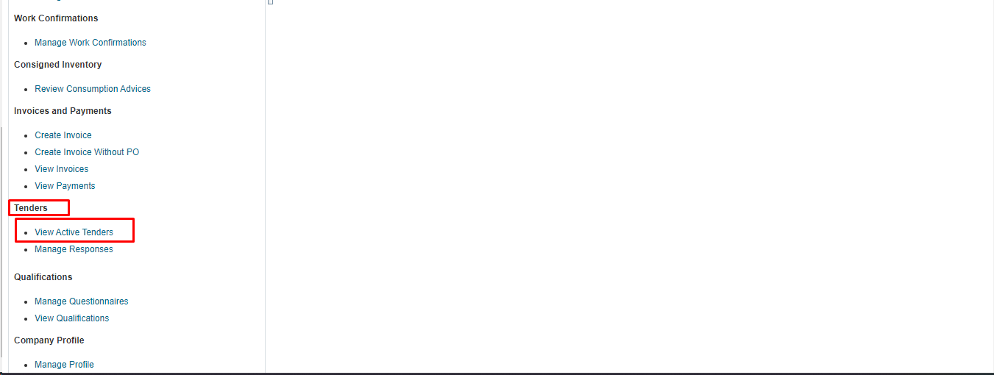
Step | Action
 | Scroll down to view Tenders View Active Tenders.

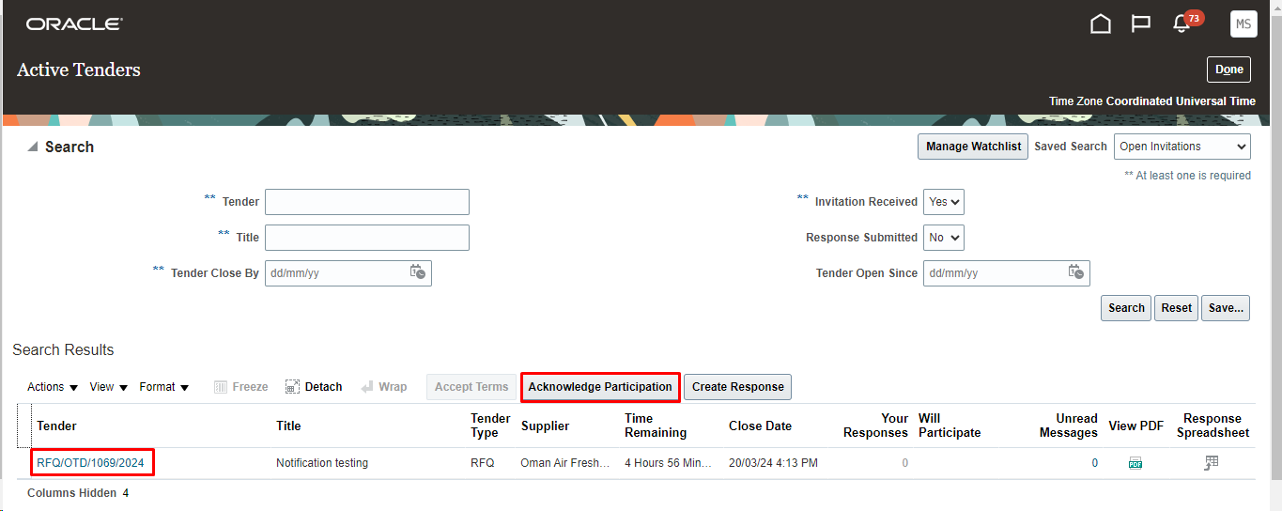
Step | Action
 | Click on Acknowledge Participation to acknowledge on particular RFQ.

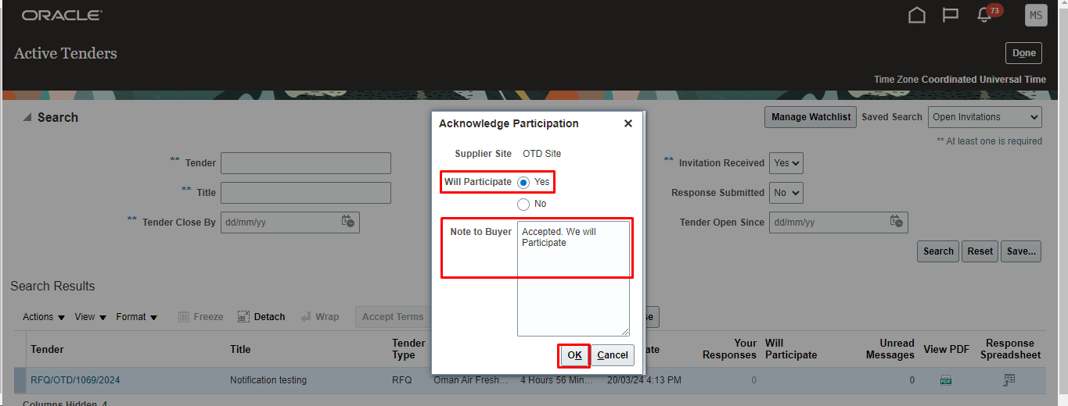

Step | Action
 | Click Yes to participate and provide any note to buyers if needed. Click Ok to send the acknowledgment.
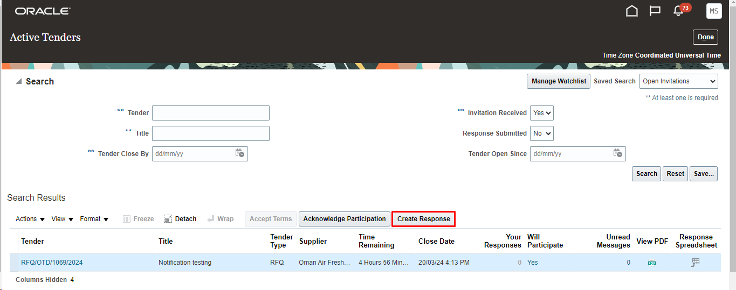
Step | Action
 | Click Create Response button to provide the response for the RFQ selected.

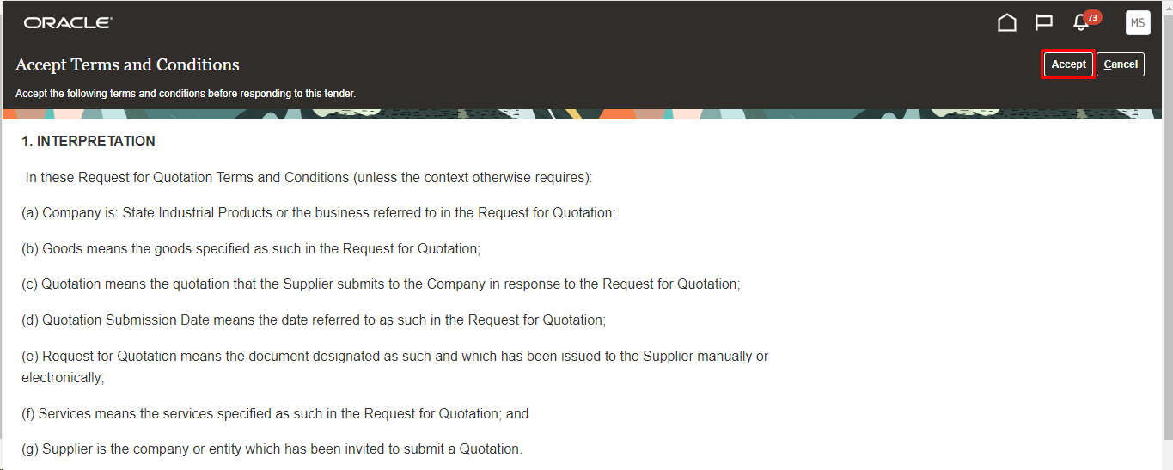
Step | Action
 | - Accept the terms and condition before providing the response to the Tender.

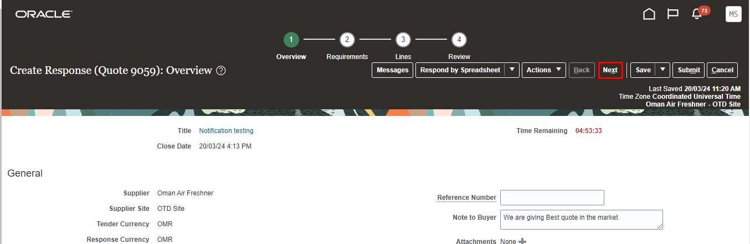
Step | Action
 | Provide any Notes to the buyer and attachments if needed in the Overview Tab. Click Next

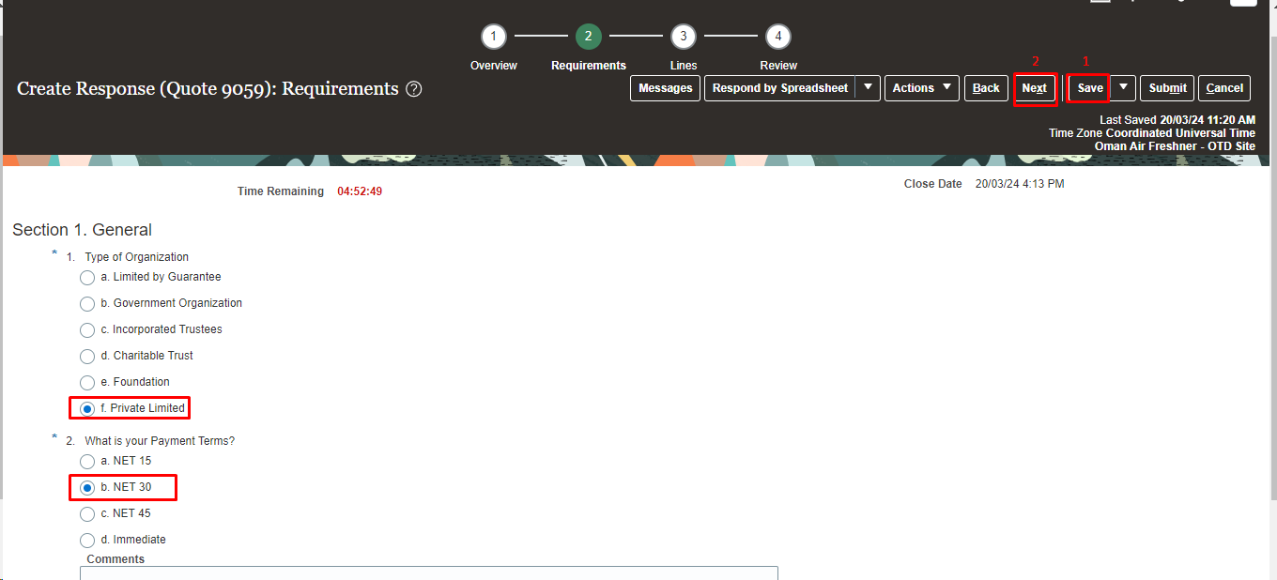
- Supplier user can enter free form text in the text boxes provided.
  - You can enter a single line of text or multiple lines in a text box.
  - For Number fields, you enter a numeric value. The acceptable format for the number depends on your user preference.
  - For Date fields, you can use the date picker to select a value.
  - For Date and time fields, you can use the date picker to select the date, the time picker in the format: hours + minutes + seconds, and then the applicable AM or PM radio button.
  - For URL fields, you enter a regular internet address.
Step | Action
 | Provide the Response for the requirements from Buyers company.
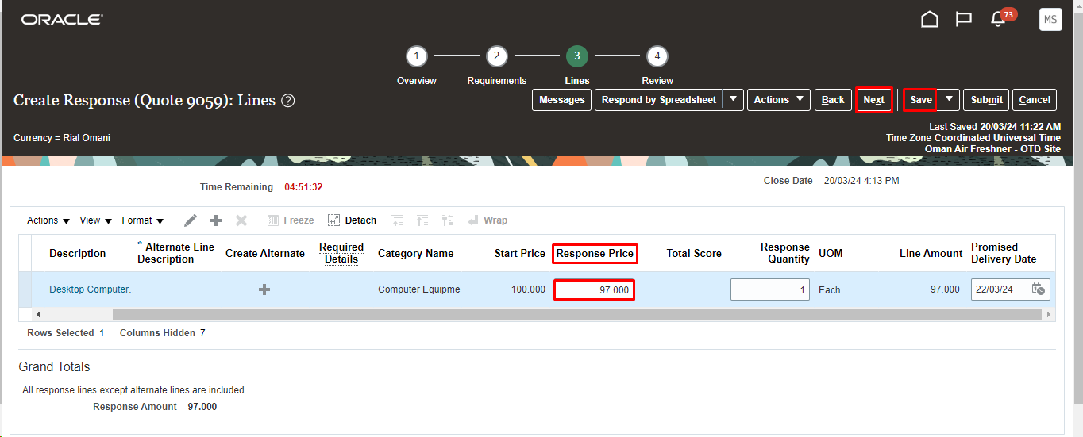

Step | Action
 | Provide the Response Price for the line and response quantity in the provided field. Click Save and Next.

Note: If the negotiated item is not available, you can click “Create Alternate Line” and enter the availbale item matching with the negotiated item.
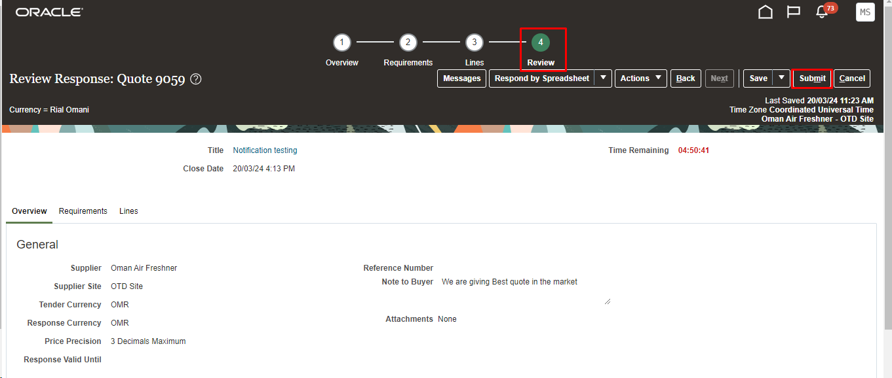
Step | Action
 | Click On Submit Button after Review

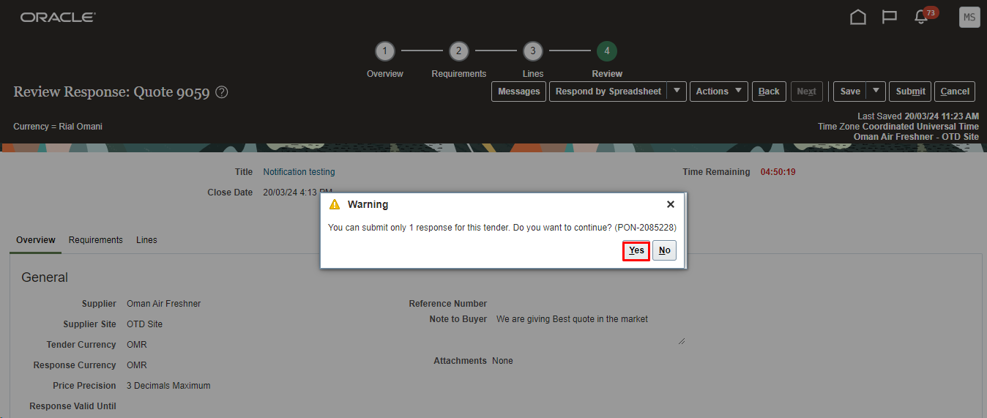
Step | Action
Click Yes on the Warning Messages.
Note: Sometimes based on the RFQ Controls the Response revision will not be allowed.so fill the response without any errors

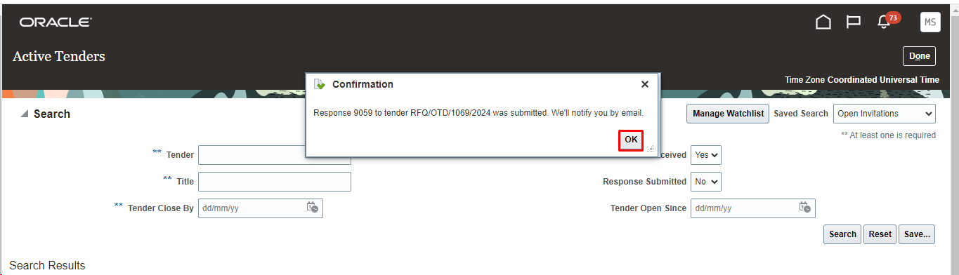

Step | Action
 | Click Ok on the confirmation Messages. On submission the RFQ owner will be notified of the Response Quotes.
 | End of the Procedure

